**ESET 219 Homework 3**

**Name:**

**Section:**

1. Simplify the following Boolean expressions

a. ̅𝑋̅̅𝑌̅̅̅+̅̅̅(̅̅𝑌̅̅+̅̅̅𝑋̅̅̅)

(XY')'(Y+X)'

X'+Y'(Y'X')

X'Y'+X'Y'=X'Y'

* 1. 𝑋’𝑌𝑋 + 𝑋𝑍

0+XZ=XZ

* 1. 𝐴̅𝐵̅𝐶̅ +

̅𝐴̅̅+̅̅̅𝐵̅̅̅+̅̅̅𝐶̅̅ + 𝐴̅𝐵̅𝐶̅𝐷

A'B'C'+(A'B'C)+A'B'C'D=A'B'

* 1. (𝐴𝐵̅𝐶 + 𝐴𝐵̅𝐵𝐷 + 𝐴̅𝐵̅)𝐶

B'C

1. For each given schematic

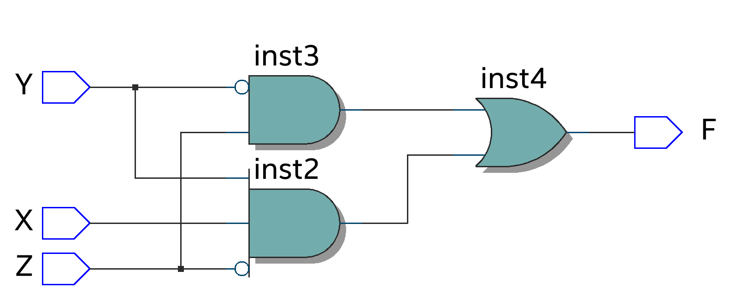

**Y**

**F**

**Z**

(XYXZ)+(X'Y'Z)=F

XY(XZ)'+XZ(XY)'+X'Y'Z

XY(X'+Z')+XZ(X'+Y')+X'Y'Z XYZ'+XZY'+X'Y'Z Y'Z(X'+X)+XYZ' XYZ'+Y'Z=F

1. Write the Boolean equation for the output F.
2. Use Boolean algebra to simplify F. Draw the simplified circuit schematic

**A**



**B**

**F**

**C**

A+(ABC)'+AB=F

A+A'+B'+C'+AB 1+AB+B'+C'

1=F

**X**

1. Given the following truth table
2. What are all the minterms?
3. What are all the maxterms?
4. Write F as a SOP equation (unsimplified)
5. Use Boolean algebra to simplify F from part c. (must show work for credit)

F=(A'B'C)+(A'BC)+(ABC')+(ABC)

A'C(B'+B)+AB(C'+C) A'C+AB=F

maxterm

minterm maxterm minterm maxterm

|  |  |  |  |
| --- | --- | --- | --- |
| A | B | C | F |
| 0 | 0 | 0 | 0 |
| 0 | 0 | 1 | 1 |
| 0 | 1 | 0 | 0 |
| 0 | 1 | 1 | 1 |
| 1 | 0 | 0 | 0 |
| 1 | 0 | 1 | 0 |
| 1 | 1 | 0 | 1 |
| 1 | 1 | 1 | 1 |

maxterm

minterm minterm

A'B'C'

A'B'C

A'BC' A'BC

AB'C'

AB'C ABC' ABC